**Instructions from Dustin**

Hi Tin,

Good Evening! After reviewing the themes, I think we'd like to move forward with this one: [POFO](https://themeforest.net/item/pofo-creative-portfolio-and-blog-wordpress-theme/21023319)

We will need a homepage that has a feature (photo / Slider) with a call to action and a blog immediately upon scroll with a footer. We will also need a few additional pages such as: Submit A Case | About Us | How It Works

We will provide the content for these pages, and can be stubbed out with Lorem Ipsum in-order to get started. We need to ensure the page has a crisp clean look and is mobile optimized. We would like some type of SEO plug-in used for the post in the Wordpress backend...maybe [Yoast](https://yoast.com/wordpress/plugins/seo/) or whatever. As discussed, I would like to utilize Zendesk for the submission of cases / contacts from the sign-up form. I do not believe that we need a place for users to register, only a submission pop-up or page. They can register with Facebook or LinkedIn and/or enter their Name, phone number, and email address. Whatever works here...possibly implement a captcha to prevent bogus submissions as well.

I'd like to remain heavily involved in the design and implementation of this project, so we don't waste time and budget on un-necessary action items. Feel free to reach out anytime! I have confidence you and your team can create what we're looking for! Please let me know your thoughts, and what I need to provide. GoDaddy Login, theme purchase / login, stock photos, etc. Also, maybe we could have a video call sometime soon (tonight, tomorrow) so we're on the same page.

Many Thanks,

**Sketch from Dustin**

Link: <https://drive.google.com/file/d/13KBJDiiUDUJRyVZeEg2_rvBCM1_tsfkD/view?usp=sharing>

**Home Page**

* Main section with Call To Action: <http://wpdemos.themezaa.com/pofo/home-creative-designer/>

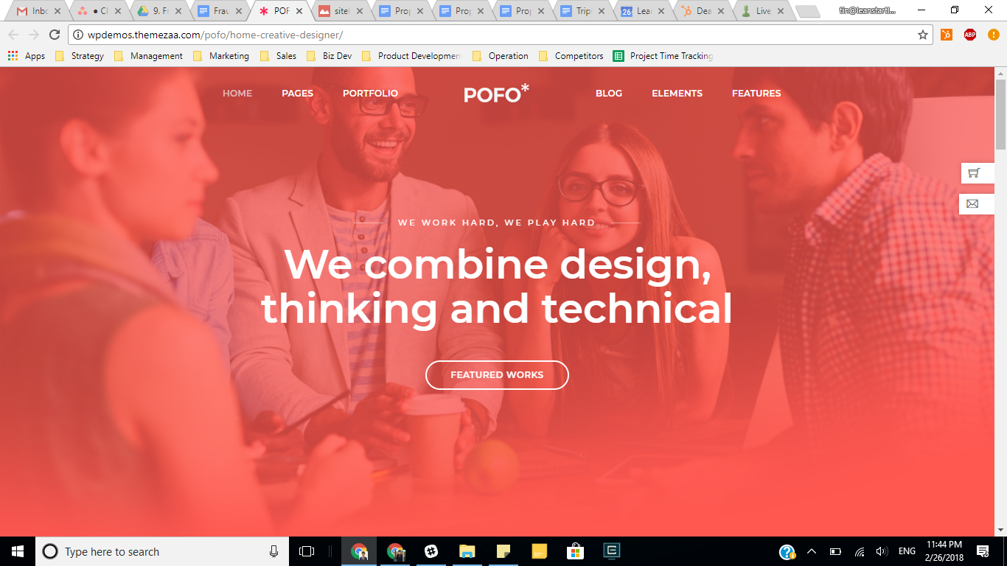

* Blog section after first scroll: <http://wpdemos.themezaa.com/pofo/home-blog-personal/>

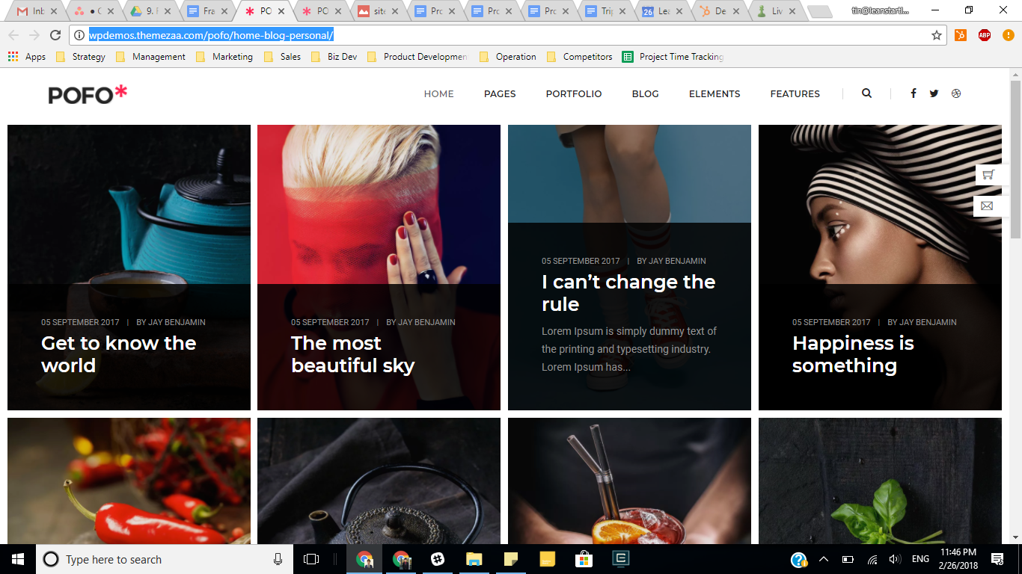

**Home Page (continued)**

* About Us section after Blog section: <http://wpdemos.themezaa.com/pofo/about-simple/>

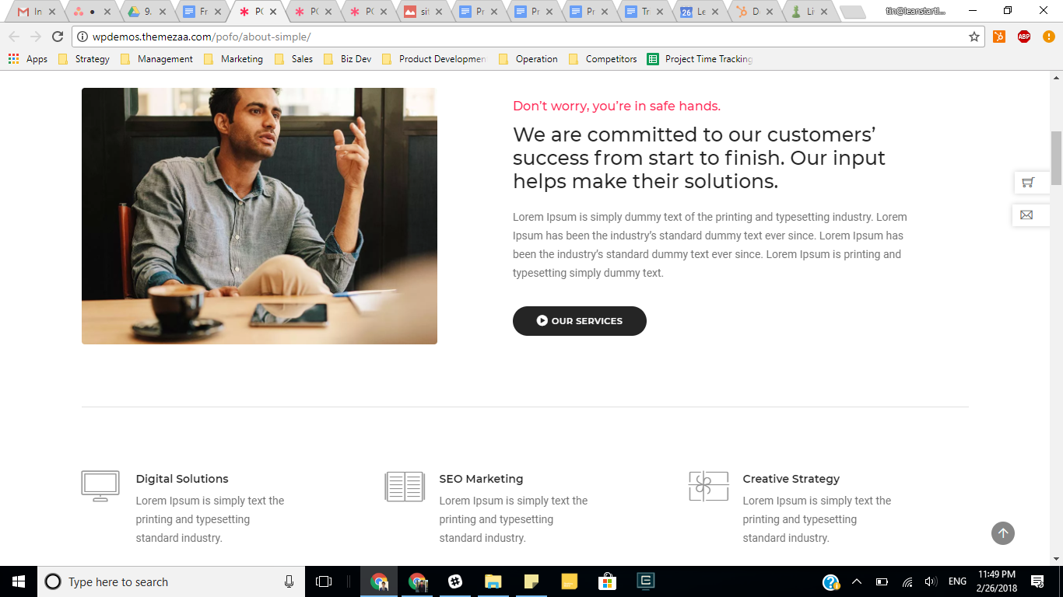

* How It Works section after About Us: <http://wpdemos.themezaa.com/pofo/services-modern/>

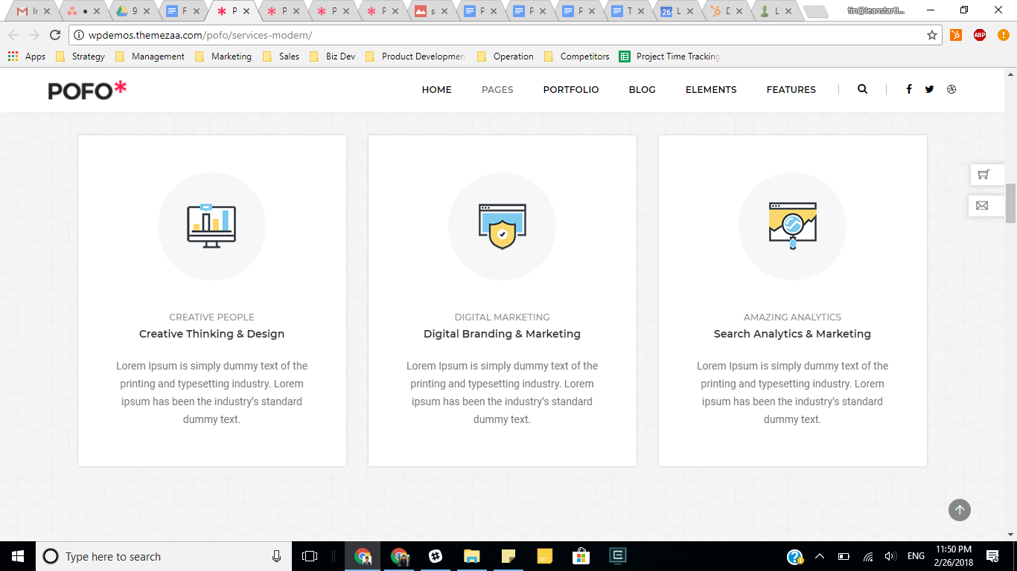

**Blog Page (full separate page)**: <http://wpdemos.themezaa.com/pofo/home-blog-personal/>

**Elements**

“Submit a Case” popup: <http://wpdemos.themezaa.com/pofo/contact-classic/>

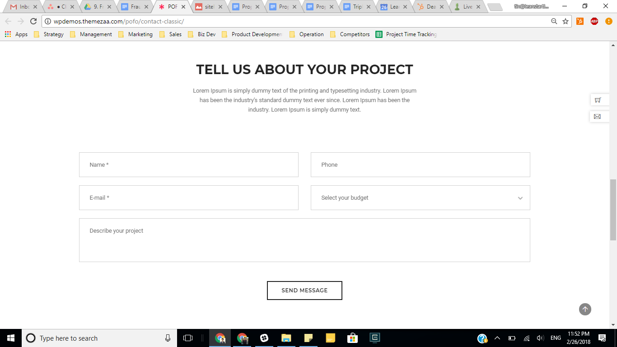

Blog Post: <http://wpdemos.themezaa.com/pofo/blog-post-layout-03/>

Footer: <http://wpdemos.themezaa.com/pofo/footer-classic-dark/>

**Materials Needed**

* ~~POFO theme~~
* ~~GoDaddy log in~~
* ~~Confirmation of page and post layouts~~
* ~~Hosting: $15/month x 12 months = $180~~
* ~~Zendesk (Support package) log in~~
* Disclaimer language
* ~~Submit form~~
* ~~Short description of the case submission process~~
* ~~Ad space: how should we structure this~~
  + ~~Can do it now~~
  + ~~View more here:~~ [~~https://wordpress.org/plugins/search/ad/~~](https://wordpress.org/plugins/search/ad/)
  + ~~Our suggestion:~~ [~~https://wordpress.org/plugins/ad-inse~~rter/](https://wordpress.org/plugins/ad-inserter/)
* ~~Retargeting~~
  + ~~Our suggestion:~~ [~~https://wordpress.org/plugins/perfect-audience-retargeting/~~](https://wordpress.org/plugins/perfect-audience-retargeting/)
  + ~~View more here:~~ [~~https://wordpress.org/plugins/tags/retargeting/~~](https://wordpress.org/plugins/tags/retargeting/)
* Content
  + Sample post
  + Stock photos
* Color scheme: blue
* Captcha plugin
* Yoast plugin (free)
* ~~Facebook plugin~~
* ~~LinkedIn plugin~~

**Project Steps**

* Gather all materials needed
* Confirm page style and layouts requirements
* Relay requirements to dev team
* Implement requirements
* Customize and iterate
* Finalize on local host
* Deploy to live host